Exercise No: LAB Exercise – 2
Course: MAI511-1 - Advanced Database Technologies

Name: Vismitaa S
Register No: 2648552

Demonstration of the Relational Model
1. Create the necessary tables for the identified database objects from the ER Diagram of your business domain with the necessary constraints (Primary Key, Unique, Not Null, Check, Default, and Foreign Key).
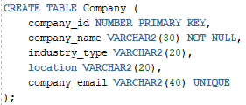
In the above figure demonstrates the sql command indicating the creation of table named “Company”. This table uses constraints such as Primary key for unique identification of the Company , Not null constraint is used in the command so that each company id has its own Company name and Unique constraint is used so that each has its own unique Company Email for their Company.

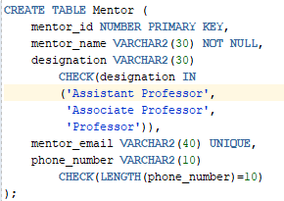
In the above figure demonstrates the sql command indicating the creation of table named “Mentor”. This table uses constraints such as Primary key for unique identification of the Mentor because there might be more than 1 mentor with the same name, Not null constraint is used in the command so that each company id has its own Mentor name assigned and Unique constraint is used so that each has its own unique Mentor Email for their Company. Also the Check constraint is used to check the length of the phone number because every phone must have only 10 numbers . If it is less than or more than 10 then the phone number is invalid.
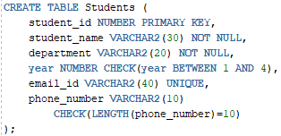
In the above figure demonstrates the sql command indicating the creation of table named “Students”. This table uses constraints such as Primary key for unique identification of the Student because there might be more than 1 student with the same name, Not null constraint is used in the command so that each student id has its own Student name assigned because each Student have their own name and it cannot be empty and Unique constraint is used so that each has its own unique Student Email . Also the Check constraint is used to check the length of the phone number because every phone must have only 10 numbers . If it is less than or more than 10 then the phone number is invalid and it also used to check whether the Student is between 1st year to 4th year.

2. Demonstrate the enforcement of constraints with necessary inputs
COMMAND:
RESULT:
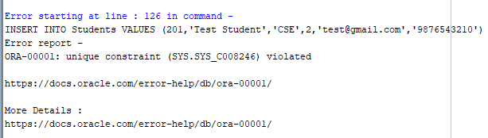
This command attempts to insert a new student record with Student ID 201, which already exists in the Students table. Since Student ID is defined as the Primary Key, duplicate values are not allowed.

COMMAND:
RESULT:
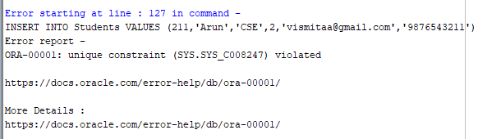
This command attempts to insert a student record using an email address that already exists in the Students table. Since the email column is defined with a UNIQUE constraint, duplicate email addresses are not permitted.
COMMAND:
RESULT:
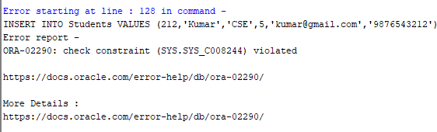
This command attempts to insert a student record with a year value of 5. The Students table contains a CHECK constraint that restricts the year value to the range 1 to 4. Since the inserted value violates this condition, Oracle rejects the record and raises a check constraint error.
COMMAND:
RESULT:
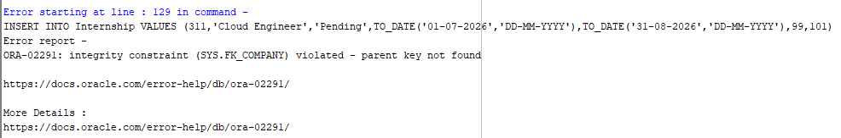
This command attempts to insert an internship record with Company ID 99. Since Company ID 99 does not exist in the Company table, the Foreign Key constraint is violated.
COMMAND:

RESULT:
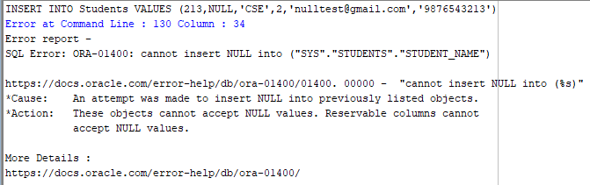
This command attempts to insert a student record without specifying a student name. The student_name column is defined with a NOT NULL constraint, which requires a valid value for every record. Oracle rejects the insertion and displays an error indicating that NULL values are not allowed.

3. Demonstrate the enforcement of constraints using the ALTER TABLE command.

COMMAND:

RESULT:
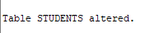
The ALTER TABLE command is used to modify the structure of an existing table. This command adds a new column named CGPA to the Students table. The data type NUMBER(4,2) allows values with up to 4 digits, including 2 digits after the decimal point.

COMMAND:
RESULT:
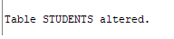
This command adds a CHECK constraint named CHK_CGPA to the Students table. The constraint ensures that the CGPA value entered for any student must be between 0 and 10. Any value outside this range will be rejected by Oracle.
COMMAND:
RESULT:
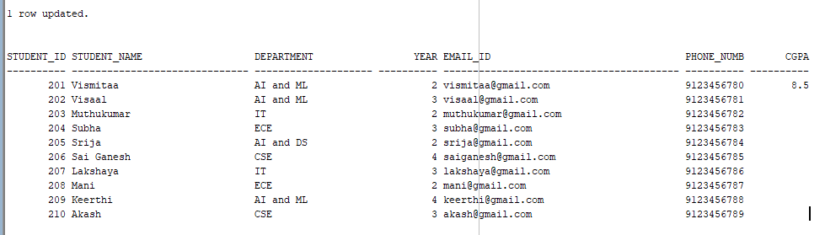
This command updates the CGPA of the student whose Student ID is 201. Since the value 8.5 lies within the permitted range of 0 to 10, the update operation is successful.

4. List the constraints enforced on each table.
COMMAND:
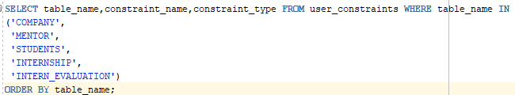

RESULT:
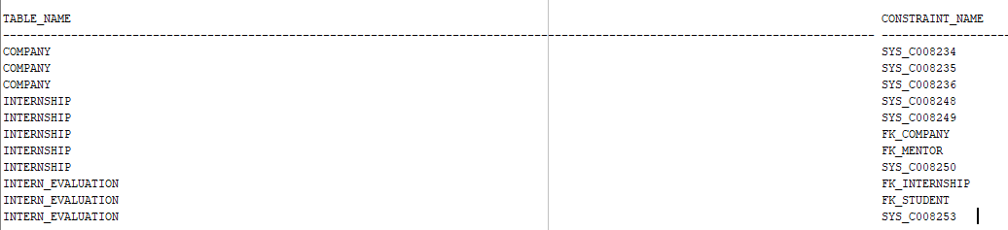

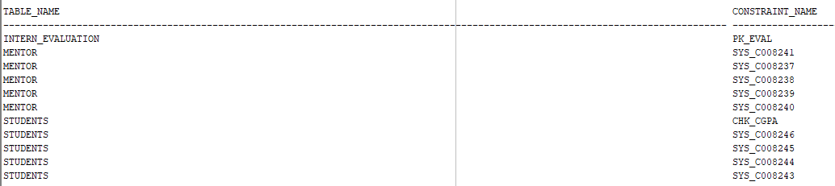

The USER_CONSTRAINTS data dictionary view is used to display information about constraints defined in the database. This query retrieves the table name, constraint name, and constraint type for all constraints enforced on the Company, Mentor, Students, Internship, and Intern_Evaluation tables. The output helps verify that the required Primary Key, Foreign Key, Unique, Check, and Not Null constraints have been successfully implemented.
5. Demonstrate dropping of any one constraint of an object.
COMMAND:
RESULT:
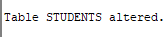
The ALTER TABLE command is used to modify an existing table. This command removes the CHECK constraint named CHK_CGPA from the Students table. After the constraint is dropped, Oracle will no longer validate CGPA values against the range specified by the constraint.

COMMAND:
RESULT:
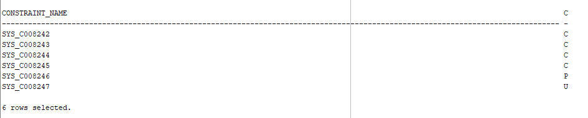
This query displays all constraints currently defined on the Students table. The absence of the CHK_CGPA constraint in the output confirms that the constraint has been successfully removed.

COMMAND:
RESULT:
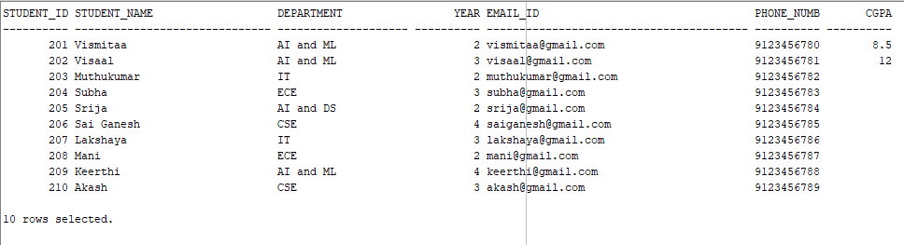
This command updates the CGPA value to 12. Since the CHK_CGPA constraint has been removed and accepts the update without generating a constraint violation error.
6. Demonstrate how data integrity is maintained by propagating changes across parent and child tables present in the database.
COMMAND:
RESULT:
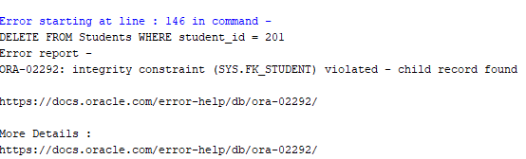
This command attempts to delete a student record that is referenced in the Intern_Evaluation table. It rejects the deletion because the Foreign Key constraint ensures that child records always reference valid parent records. Data integrity was maintained through the use of Foreign Key constraints

7. Demonstrate the Drop and Truncate Commands on the objects and display the records.
(i) Demonstrate TRUNCATE
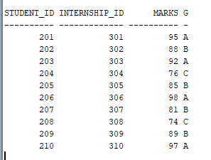
The above figure is the Intern_Evaluation table before performing truncate
COMMAND:
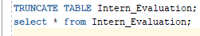
RESULT:
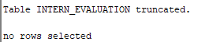
The TRUNCATE command removes all records from the Intern_Evaluation table. The table structure, columns, and constraints remain intact and displays the contents of the Intern_Evaluation table after truncation. The output will show that all records have been removed while the table still exists.
(ii) Demonstrate DROP
COMMAND:
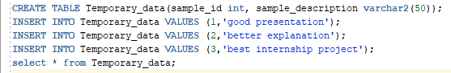

RESULT:
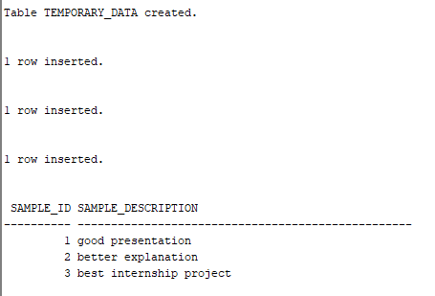
A temporary table named Temporary_data is created specifically to demonstrate the DROP command and inserted a sample record into the Temporary_data table and also displays the records present in the Temp_Test table before it is dropped.
COMMAND:
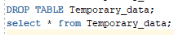
RESULT:
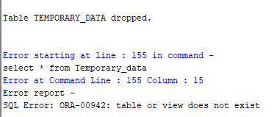
The DROP TABLE command permanently removes the Temporary_data table from the database, including its structure and generates an error indicating that the table no longer exists, confirming the successful execution of the DROP command.
In short, The TRUNCATE command was used to remove all records from a table while preserving its structure. The DROP command was used to permanently remove a table and its data from the database. The successful execution of these commands demonstrates different methods of data and object removal in Oracle SQL.

ENTERIES IN THE DATABASE
COMPANY TABLE
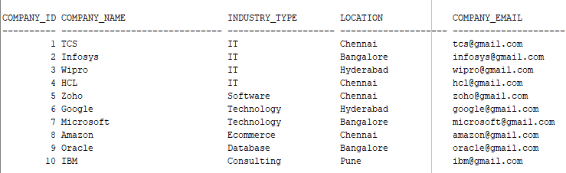

MENTOR TABLE
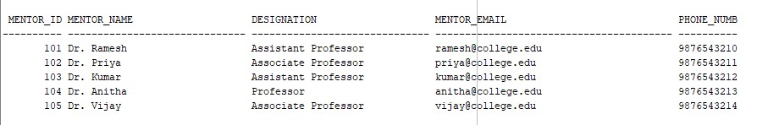
STUDENT TABLE
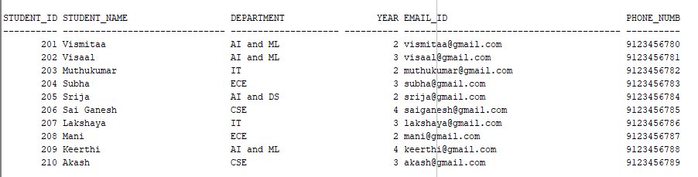

INTERNSHIP TABLE
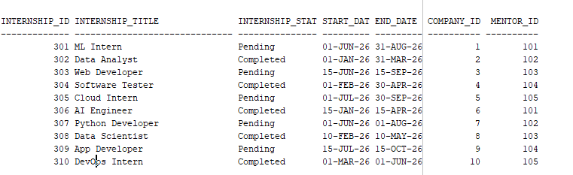

INTERNSHIP EVALUATION TABLE
